**Practical - 19**

**Aim:** Write an assembly code to copy string. (using jump, loop and string manipulation instruction)

**Description of instructions used:**

**Code:**

**Using Loop:**

include 'emu8086.inc'

**.MODEL** small

**.STACK** 100h

.data

**STRING** db 'Rajiv_Gupta'

.code

**MOV** ax,@data

**MOV** ds,ax

**MOV** si,offset String

**MOV** cx,10

loop1:

**MOV** bx,[si]

**PUSH** bx

**POP** dx

**MOV** ah,02h

**INT** 21h

**INC** si

**LOOP** loop1

**MOV** cx,10

**HLT**

**Output:**

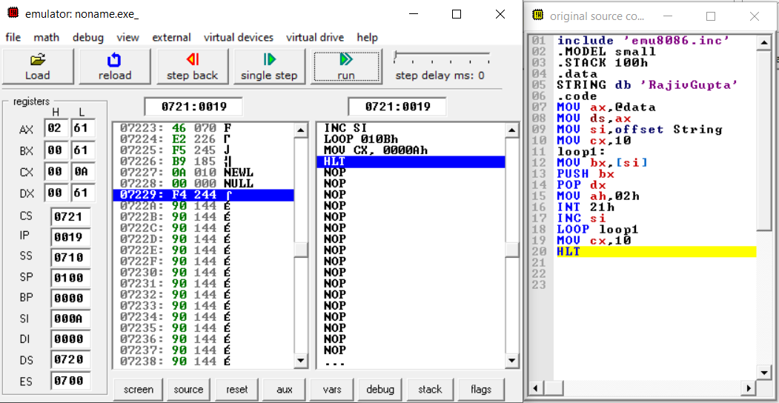

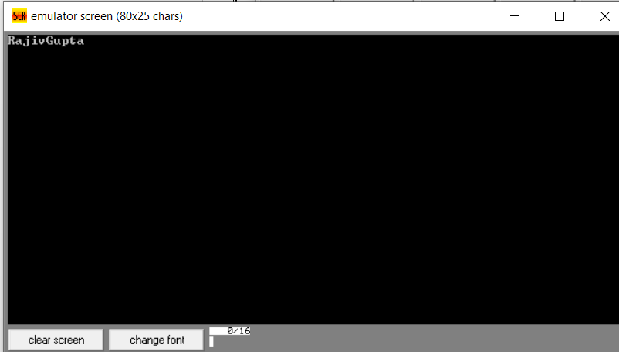

**Using Jump:**

include 'emu8086.inc'

**.MODEL** small

**.STACK** 100h

.data

String db 'RajivGupta'

.code

**MOV** ax,@data

**MOV** ds,ax

**MOV** si,offset String

**MOV** cx,10

loop1:

**MOV** bx,[si]

**PUSH** bx

**POP** dx

**MOV** ah,02h

**INT** 21h

**INC** si

**DEC** cx

**JNZ** loop1

**MOV** cx,10

**HLT**

**Output:**

